Phase 4: Deployment and Update Set Packaging

1. Phase Overview
The primary objective of Phase 4 is to package all technical artifacts, configuration metadata, catalog configurations, and Flow Designer workflows developed during the project into a dedicated ServiceNow Update Set. This ensures seamless lifecycle management, audit traceability, and error-free code migration from Development to Test/Production environments.

2. Configuration Details

A. Update Set Metadata
- Update Set Name: Car Rental Request Setup
- Application Scope: Global
- State: Complete
- Target Artifacts Captured: Catalog Item, Variables, Choice Lists, Flow Designer Flow, Trigger Rules, Business Rules.

B. Artifact Capture Specifications
Artifact Category | Captured Element Name | Description / Metadata
Catalog Item | Car Rental Request | Main catalog item definition under Transportation Services category.
Variables Set | 7 Core Variables | To make a request, requested_date, pickup_location, drop_location, Duration, car_type, Reason.
Workflow / Flow | Car Rental Request Flow | Flow Designer triggers, manager approval logic, and SCTASK creation actions.
Choices | car_type & Duration choices | Dropdown options (SUV, sedan, mini) and radio button options (1-5 days).

3. Execution & Verification Steps
- Update Set Creation & Tracking:
  - Navigated to System Update Sets > Local Update Sets.
  - Created a new Update Set named Car Rental Request Setup and set it as the current active set before starting configuration work.
- Artifact Verification:
  - Navigated to Customer Updates related list inside the Update Set.
  - Verified that all catalog items, variables, choices, and Flow Designer components were recorded without errors.
- State Completion & Export:
  - Changed the Update Set state from In Progress to Complete.
  - Saved the record and executed Export to XML to store the deployment package locally for instance migration.

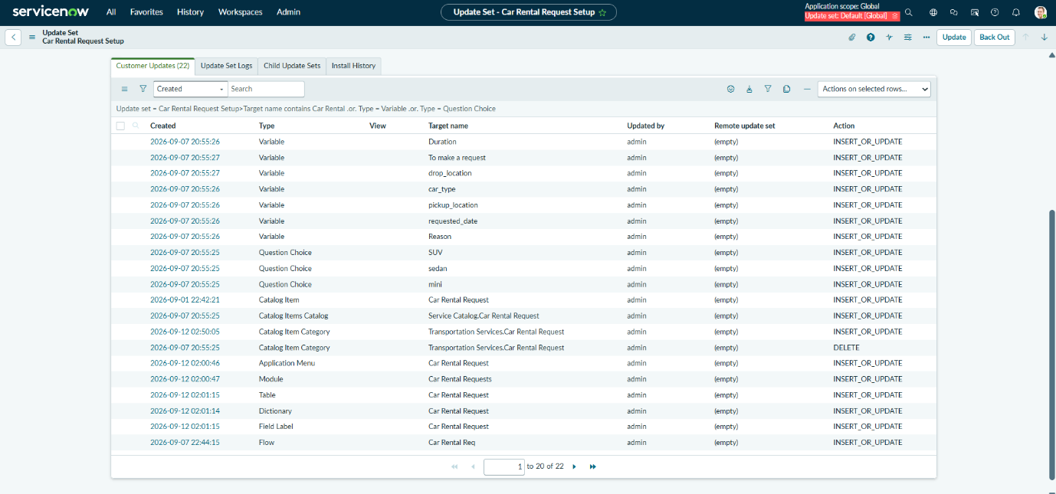

Figure 4.1: Customer Updates list capturing all project artifacts inside Car Rental Request Setup Update Set

